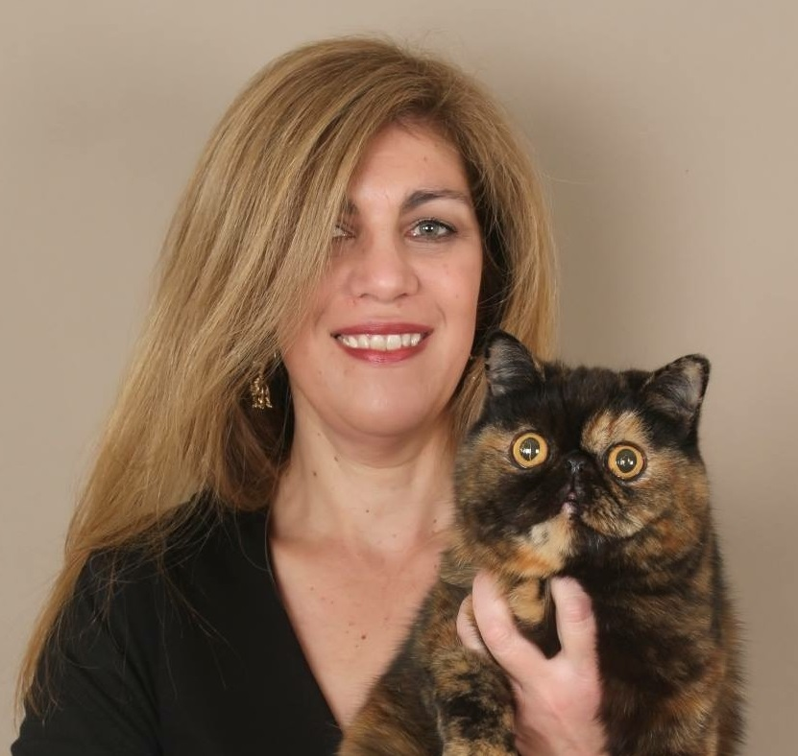 | Brenda Neukircher  neukircher@lawcircle.co.za
CAT JUDGING
Judging Qualifications
Persian & Exotic
Mediumhair breeds
Foreign breeds
Siamese/Oriental

Status: All Breeds

International Judging: France, Italy, Germany, USA (for CFA), Malta, Sweden, China, New Zealand, Australia

CAT FANCY INVOLVEMENT
Club/s: 1998 to date: stewarded, judged and exhibited at CFSA, SACC, WCF and Independent Clubs in RSA

Governing Council:
SACC: Ethics Committee
CFSA: Secretary of EXCO 2015

Judges Council:
SACC : Vice-Chair CJI for 2 years
CFSA:
Chair of Gauteng Judges Forum 2005, 2005, 2016
Chair of NCJE: 2015
Member of NCJE: 2016
Member of CFSA Breed Council: 2013, 2015, 2016

Cat of the Year
SACC:
L’Exquisite Beau Monde COTY 2006
Almathea Blue Marine of L’Exquisite – Best Entire 2019

CFSA:
L’Exquisite Count Pushkin COTY 2022
L’Exquisite Showbiz – Neuter of the Year 2004
L’Exquisite C’est Si Bon of Tres Jolie – Kitten of the Year 2005
L’Exquisite C’est Si Bon of Tres Jolie – COTY 2008
Palmetto’s Victor of L’Exquisite – COTY 2009
L’Exquisite Apres Midi – COTY 2010
L’Exquisite Oracle – Kitten of the Year 2010
Ormeryds Sundover of L’Exquisite – Male of the Year 2010
L’Exquisite Le Bonheur – COTY 2011
L’Exquisite Incroyable – Kitten of the Year 2013
IxieDixie Brownie of L’Exquisite – Male of the Year 20153
CAT BREEDING
Registered Cattery/Catteries
L’Exquisite

Breed/s
Breed: Persians & Exotics
Previously Owned: SH Munchkin & Snow Spotted Bengal
Now own: LH Munchkin, 2 Siberians

Cat Show History

I have been privileged to have owned and shown many beautiful cats of different breeds over the past 29 years and have achieved with these amazing cats, feats I could only dream of: litter of the year, sire of the year, dam of the year, cattery of the year and more. Many of my cats have gone on to participate in a COTY event and, no matter what they have achieved, have always done me proud.

CAT RELATED ARTICLES WRITTEN OR PRESENTED
Title:
Editor of All About Cats Magazine for many years
Judges Symposium SACC : Smoke and shaded Persian colour development
CFSA Symposium: Presentation on Maine Coon, Norwegian Forest Cat, Birman and Ragdoll

SKILLS
Languages Spoken – English, Afrikaans (and a smattering of French)
Languages Written – English, Afrikaans

