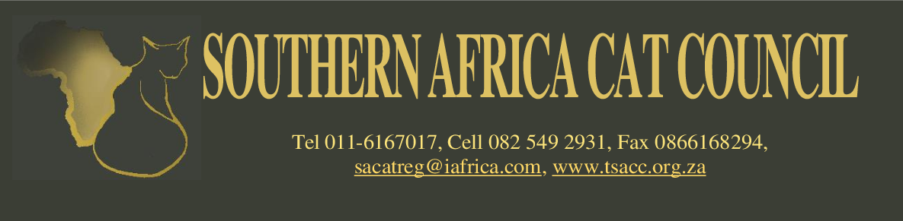

THE SA CAT REGISTER

SACC MERIT CLUB MEMBERS

PLATINUM MEMBERSHIP
To become a member, a cat needs to be awarded 100 Supreme Certificates

NAME OF CAT | REGISTRATION  NUMBER. | OWNER | BREEDER | BREED
ALLY’S CAT NUTMEG | 20307054 | LASHAN & SHER MOODLEY  SINGH | A. RENWICK | ASIAN
AVANTE GARDE SMILING THOMAS OF GAEBLEFIELD | 20502205 | VICTORIA ANNE HARRIS | P. VAN DEN HEEVER  & P. VAN TONDER | SELKIRK REX
C’EST L’AMOUR FERRERO ROCHE RQ NQ | 21212086 | LIZETTE CRONJE | L & S MOODLEY SINGH | PERSIAN
KONDICOON MONTGOMERY OF HIGHLANDERS | 20708138 | CAROL MIDDLETON | T. & J. TAYLOR | MAINE COON
SAN-SHING’S KINGS BEST | 21111153 | M BOLTON | P & T PRIME | SIAMESE
SANUK MIKO | 21112121 | DINA FREITAS | D FREITAS | DEVON REX
TIMSHAY CORELLI | 20310251 | SHIRLEY ADDISON | SHIRLEY ADDISON | BIRMAN
TRÉS JOLIE MONTEGO BAY | 20710248 | LASHAN & SHER MOODLEY  SINGH | C. DANZIGER | PERSIAN
WATERLEE RASASAYANGRAGS MATTHEWIS (IMP) | 20708143 | IVO HUISMAN | T ZANEN & M HEIJNIS | RAGDOLL

GOLD MEMBERSHIP
To become a member, a cat needs to be awarded 75 Supreme Certificates

NAME OF CAT | REGISTRATION  NUMBER. | OWNER | BREEDER | BREED
FLAMBOYANT ALVIN L’MEUR (ASAA) | 20508112 | RENE VAN WYK | M. NEL | PERSIAN
MUTTIS SNOW DRAGON | 20508105 | M.J. VAN DYK | M.J. VAN DYK | SIAMESE
NOOITGEDACHT ENGELTJIE | 20610126 | SANDY GUNST | SANDY GUNST | BIRMAN
THE LEGENDS PEARL HEART | 20809171 | BEVERLY SMULLEN | PETRA SMITH | NORWEGIAN FOREST CAT
MILKWOOD’S HEY THERE D’LILA RQ NQ | 201711091 | DAWN KEYTER | ADELE BREEDT | PERSIAN
WATERLEE RASASAYANGRAGS MATTEWIS (IMP) | 20708143 | IVO HUISMAN | T.ZANEN & M. HEIJNIS | RAGDOLL

SILVER MEMBERSHIP
To become a member, a cat needs to be awarded 50 Supreme Certificates

NAME OF CAT | REGISTRATION  NUMBER. | OWNER | BREEDER | BREED
ABYZULA RYDELL’S AMBASSADOR(ASAA) | 21404046 | ADRI SWART | J. LEWIS | ABYSSINIAN
ALLEY'S CAT NUTMEG | 20307054 | LASHAN MOODLEY & SHER SINGH | A. RENWICK | ASIAN
C’EST L’AMOUR PRINCE OF PERSIA | 21103125 | LIZETTE CRONJE | L. & S MOODLEY SINGH | PERSIAN
CHATTAPAWS ROGER (ASAA) | 20312196 | RENE VAN WYK | S. FINDLAY | PERSIAN
FLAMBOYANT LIPPY THE LIONESS (ASAA) | 20807095 | CARINA LANGNER | M.C. NEL | PERSIAN
FLAMBOYANT THOM-TOM (ASAA) | 20903187 | CARINA LANGNER | M.C. NEL | PERSIAN
GEEDEE'S DOM PEDRO | 20712089 | BEVERLEY & STEPHEN SMULLEN | A.G. GAW | MAINE COON
JALBERTUS BRETTACHTAL'S DEUS JUPITER (ASAA) | 20803217 | S. MARSH, C. PRETORIUS & H. VAN SCHOOR | S. MARSH, C. PRETORIUS & H. VAN SCHOOR | PERSIAN
MAI-THAI’S CATSANOVA | 20812033 | CHARLENE DU TOIT | C. VAN DER RIET | SIAMESE
MUTTI’S UNFORGETTABLE RQ NQ | 21305028 | MARLENE VAN DYK | MARLENE VAN DYK | SIAMESE
THE LEGENDS ERNEST HEMINGWAY | 20809165 | ALYSSA SMULLEN | PETRA SMITH | NORWEGIAN FOREST CAT
TRÉ'S JOLIE MONTEGO BAY | 20710248 | LASHAN MOODLEY & SHER SINGH | C. DANZIGER | PERSIAN
WESTWOOD'S DARRA OF SURREY | 20408064 | HELEN GRIFFITHS | GAIL NEL | ORIENTAL
WIZZ BILLY THE KID | 21105063 | RITA WISEMAN | RITA WISEMAN | SIAMESE
WIZZ SUNDANCE KID | 21105065 | RITA WISEMAN | RITA WISEMAN | SIAMESE

